The COVID-19 Pandemic and its Impact on Maryland State Parks

Brian Horlick-Cruz, Ioana Draghici, Gabriel Wilkins, and Guido Frega

GES 462/662, Fall 2020

***Project summary***

One of the many aspects of daily life which the COVID-19 pandemic has impacted is our usage of space. Continually throughout the pandemic, but especially early on when initial lockdowns and emergencies were declared, the ways in which we used space changed drastically. Living spaces became sites of work and school, public spaces often became mostly empty, and many spaces of recreation or socialization were shuttered in an effort to slow the spread of this new disease. Just as spring started to come to the United States, most people were urged to stay home and stop the spread.

This project aims to understand more clearly how these changes have impacted green spaces in Maryland, focusing on how the use of state parks have played out across both time and space. More specifically, we looked at whether changes in park usage have differed in urban, suburban, and rural areas, as well as whether park usage changes were correlated with COVID-19 cases. We created maps and performed statistical tests in order to investigate spatial relationships, and charted usage data over time to explore temporal trends. Although Maryland parks did see increased usage overall, there were no strong correlations between virus cases and usage, and trends over time suggest that park usage was tied more to shutdowns and other mitigation measures than directly to actual cases of COVID-19.

***Project Justification & BAckground***

Coronavirus (COVID-19) is a highly infectious disease that is spread by the droplets released in the air from those who have the virus. The first confirmed case of coronavirus in Maryland was detected on March 5th, 2020. Only 4 days later, Governor Larry Hogan began enacting COVID-19 restrictions, which drastically affected the lives of every citizen. As COVID-19 cases continued to rise in Maryland, more actions were taken to ensure the safety of its citizens. These restrictions involved closing down public schools, businesses, and all non-essential public spaces. At the beginning of the pandemic, this also included most state and federal green spaces. However, as COVID-19 numbers began to decrease and stabilize, restrictions on certain public spaces were eased. Judging from social media and news discussions, especially in the spring and summer of 2020, one of the few types of public spaces that did remain available for use were parks/green spaces.

With the persistence of restrictions on indoor public spaces, green spaces began to grow in popularity. The demand for more parks and outdoor green spaces has increased since the beginning of the pandemic (Geng et al. 2020). Whether beaches, forests, reservoirs, or trails, many public parks across Maryland seemed to experience an increase in the number of visitors compared to previous years. Anecdotal evidence seemed to indicate that people were using parks as places to exercise, socialize safely, and seek refuge from the monotony of staying at home.

The goal of this project was to identify how the COVID-19 pandemic affected, both spatially and temporally, the number of visitors using different green spaces around Maryland. Other studies have had similar aims, but many have only looked at the impact that COVID-19 had on urban parks. In one such study, they concluded that the use of urban green spaces has increased since the beginning of the Coronavirus pandemic, as did the demand for more green space (Geng et al. 2020). This correlates with our findings that, overall, most of the green spaces in Maryland saw increased visitation since the beginning of the pandemic. This research is important to local and state governments, both in helping them understand what affects demand for - and use of - green spaces, as well as how to best plan and manage them alongside public crises similar to the COVID-19 pandemic.

***Data & Methods***

Our analysis aimed to answer the following questions: (1) how has park visitation changed in relation to the COVID-19 pandemic and its associated shutdowns, and (2) what are the relationships between park visitation and regional trends in COVID-19 cases? We approached these questions by primarily working with tabular data from a variety of Maryland state government agencies. Geospatial data on the location of Maryland State Parks and COVID-19 case numbers were sourced from the Maryland Open Data Portal, while detailed visitation numbers from individual parks were supplied directly via email exchanges by staff members at the Maryland Department of Natural Resources.

The first step in the creation of the dataset used in our analysis was developing a standalone shapefile for Maryland State Parks. This was done by generating a new shapefile from a selection of the Maryland Green Infrastructure Hubs and Corridorsdataset, which included information on state parks. Thereafter, spreadsheets with park visitation numbers were edited and formatted so that they could be joined to the shapefile’s attribute table. Park visitation data was moreover edited to reflect only day-use visitation numbers, excluding camping reservations or other data so as to narrow the focus of the study.

Once park visitation data was reduced to day-use data only, some records - representing parks which did not have data for, or may not have been open in, 2019 - were deleted from the 2020 data so that visitation across the two years could be compared. The absolute change in visitor numbers per park from 2019 to 2020 was calculated, as well as the change in visitor numbers as a percentage of the total number of 2019 visitors. These data were joined to the state parks shapefiles and displayed proportionally based on the direction and magnitude of the change in visitation.

Finally, this shapefile was spatially joined to a separate one containing information on the cumulative COVID-19 cases in the state grouped by zip code. The attribute table for this shapefile was then exported as a comma-separated values file and imported into STATA statistical analysis software for further processing.

Once in STATA, information on the population of each zip code was joined to the main dataset from a Maryland census dataset. New group rank categorical variables were generated with this data, along with ones for COVID-19 case numbers, total visitation numbers for 2020, and the net change in visitation between 2019 and 2020. COVID-19 case values, total park visitation numbers, and zip code population were grouped by equal intervals, whereas the variables showing park visitation change were given extra categories in which all negative-changes were grouped together. Additionally, a bivariate categorical value was generated to indicate the presence or absence of parks in zip codes. A series of Pearson’s Chi-2 tests were then conducted in order to assess any statistically significant associations between (1) park visitation and COVID-19 case numbers, (2) zip code population and park visitation, and (3) zip code population and COVID-19 case numbers. Chi-2 tests were supplemented with gamma values in order to assess the strength of the associations. For paired variables that showed a statistically significant association, simple Order of Least Squares (OLS) regression models were produced using their corresponding continuous variables to further observe the strength and direction of these relationships. All tests were assessed at the 0.05 significance level.

In addition to this dataset, a separate one was generated to examine the trends in monthly visitation rates and COVID-19 cases in Maryland, sourced from the state COVID-19 dashboard. A dummy variable was created to represent months, while total monthly park visitation numbers for 2016 - 2020 and monthly COVID-19 numbers were added so that they corresponded appropriately with it. This dataset was then used to generate time-series line graphs using STATA, with trends being compared to important socio-political events in Maryland’s COVID-19 management scheme and further comparison between the changes in visitation over recent years.

***Results***

2020 was marked by an unambiguous increase in state park visitation in Maryland, with average monthly increases of 457,463 visitors. This trend initially became pronounced in February, but leveled off by March and remained stable through April. This pattern coincides with the declaration of a state of emergency due to COVID-19 (March 5), closures of schools and public spaces (March 16th), and the statewide stay-at-home order (March 30th). Thereafter, the month of May began a period of substantial increases in visitation, with an increase of 900,258 day-use visitors that month and peaking at 995,814 in June. This corresponds closely with the commencement of the state’s reopening from strict social distancing measures, the first phase of which began on May 15. The most recent uptick in cases thereafter began following the state’s entry into the third and final stage of reopening on September 21st, with cases increasing by 125% between September and October and 255% between October and November (WBALTV, 2020).

While the relationship between park visitation and social distancing measures are relatively clear, correlations between park visitation and COVID-19 case numbers are much less apparent. The monthly change in new COVID-19 cases has fluctuated irregularly throughout this same period, with the steepest increase in cases between October and November overlapping with the steepest decline in park visitation. However, it should be noted that the data was obtained in late November and prior to the Thanksgiving holiday, which may have resulted in higher visitation numbers than presented here.

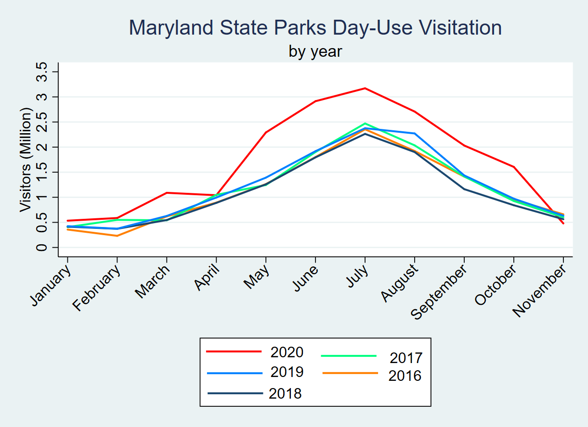

*Figure 1--Cumulative Day-Use Visitation of State Parks by Year*

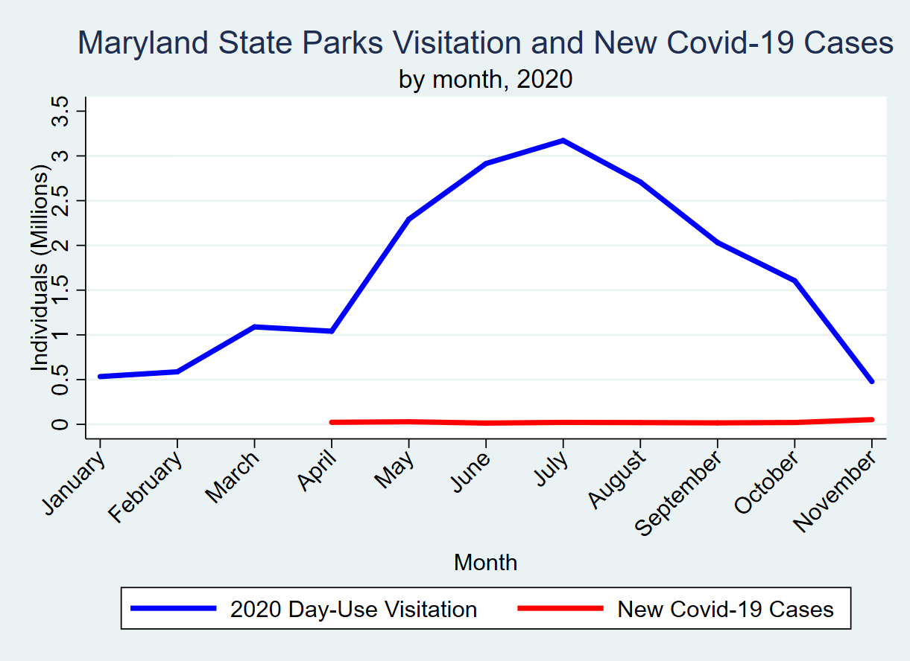*Figure 2--Cumulative Monthly Day-Use Visits and Covid-19 Cases, 2020*

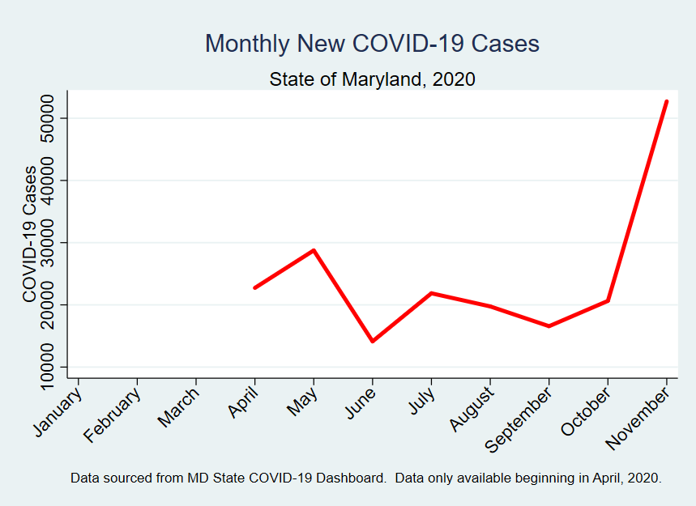

*Figure 3--New COVID-19 Cases, Maryland 2020*

The overall increase in park visitation to Maryland occurred in parks across the state. More parks saw increased visitation, and per-park visitation increases were, on average, larger than per-park visitation decreases. No clear visual trend in visitation change emerges which would enable one to distinguish between urban, suburban, and rural counties. Almost every county had a park that saw an increase in visitation as well as one which saw a decrease. While most of the parks which saw large decreases appear to be in more rural areas, many parks with smaller decreases, which may add up to similar total changes, are within more densely populated counties. And visitation increases, both large and small, can be found in densely populated as well as sparsely populated counties.

A similar absence of spatial trends seems to emerge when visually comparing park visitation to COVID-19 cases. Zip codes with large numbers of cases are adjacent to parks with both increases and decreases in visitation, and although many parks with large visitor increases are near areas with more COVID-19 cases, the rule does not hold for all parks or high-case areas. With smaller changes in visitation, the distribution is even more of a mixed bag, with changes both negative and positive found in areas with high and low case numbers.

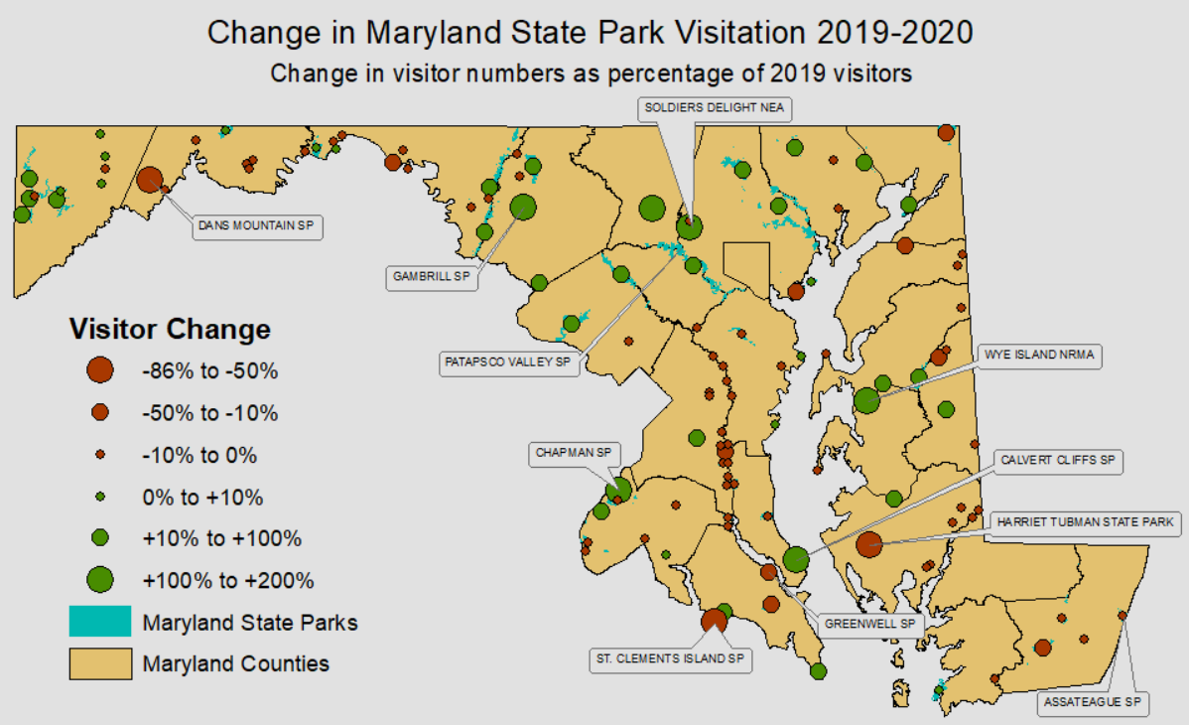

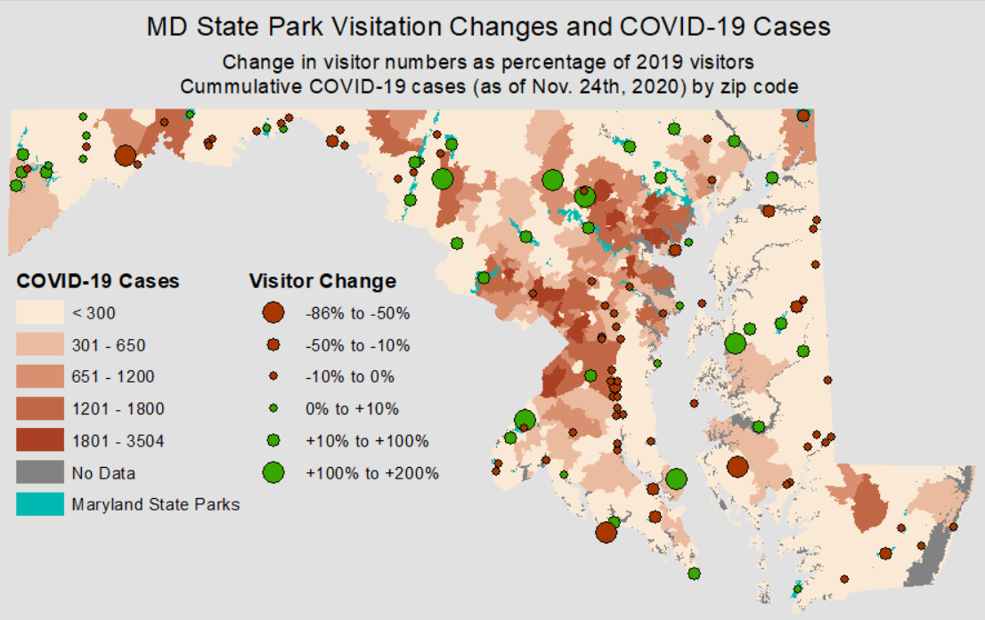

Statistical tests helped to further analyze this complicated relationship. Results from the Chi-2 tests revealed no statistically significant associations between cumulative COVID-19 cases and the presence of a park in zip codes (*x2=*3.0163, 3 *df, p=*0.389), cumulative COVID-19 and net park visitation change (*x2=*16.8208, 9 *df, p=*0.52), COVID-19, and zip code population and net park visitation change (*x2=*12.1701, 9 *df, p=*0.204). Weak statistically significant associations were observed between total 2020 visitation and cumulative COVID-19 cases (*x2 =* 32.9035, 15 *df, p =* 0.005, gamma = 0.2913) and total visitation and zip code population (*x2 =* 36.4706, 15 *df, p =* 0.002, gamma = 0.4107), while a strong association was seen between zip code population and cumulative COVID-19 cases (*x2 =* 231.2671, 9 *df, p* < .0005, gamma = 0.8899).

The nature of these relationships was further reflected by subsequent regression models, shown in Figures 4 - 6. Based on these models, every additional park visitor may be linked to a 0.00015 increase in COVID-19 cases, explaining approximately 5% of the variation in case numbers. Likewise, every additional member of a zip code’s population may be linked to an increase of 32.98 park visitors and 0.798 COVID-19 cases, accounting for approximately 6% of the variation in park visitation and 76% of the variation in case numbers.

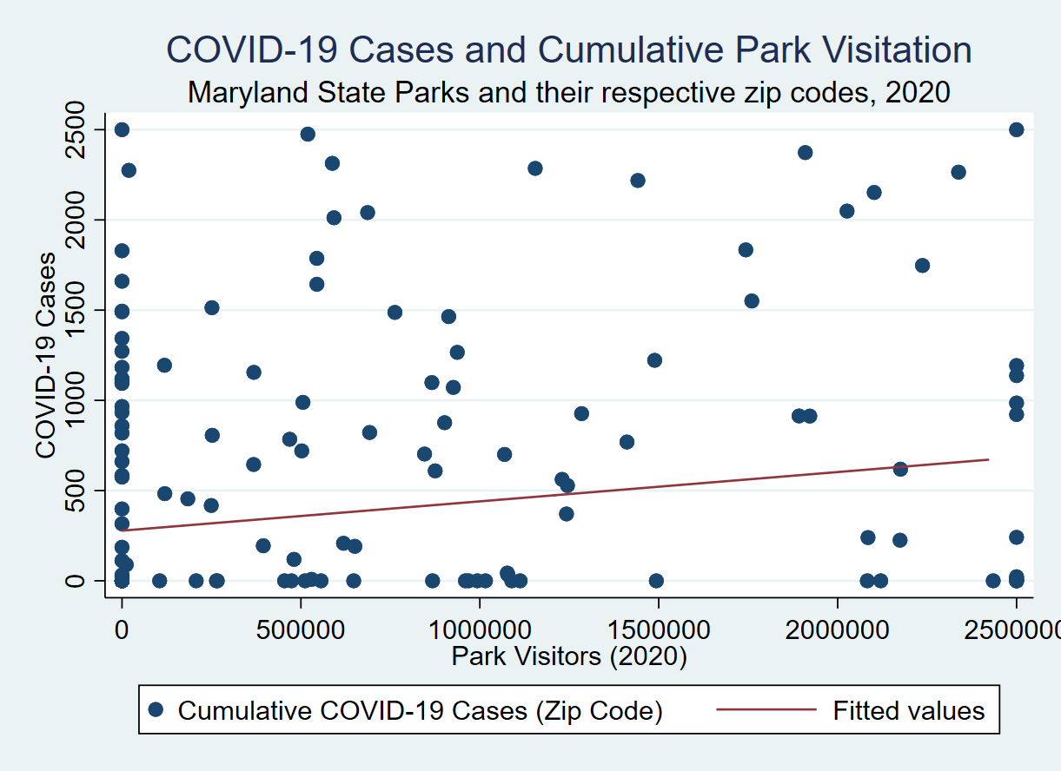

*Figure 4--Regression Model for Cumulative COVID-19 Cases and 2020 Park Visitation. N = 174, F(1, 172) = 9.74, p = 0.002, R2 = 0.0536*

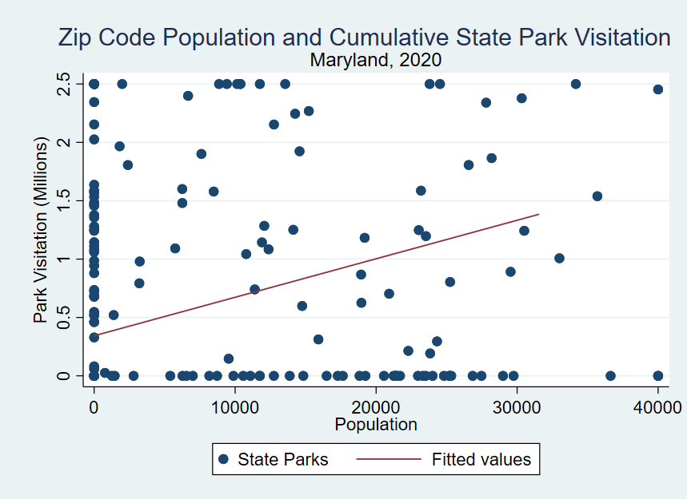*Figure 5--Regression Model of Zip Code Population and 2020 Park Visitation. N = 173, F(1, 171) = 11.82, p = 0.0007, R2 = 0.0646*

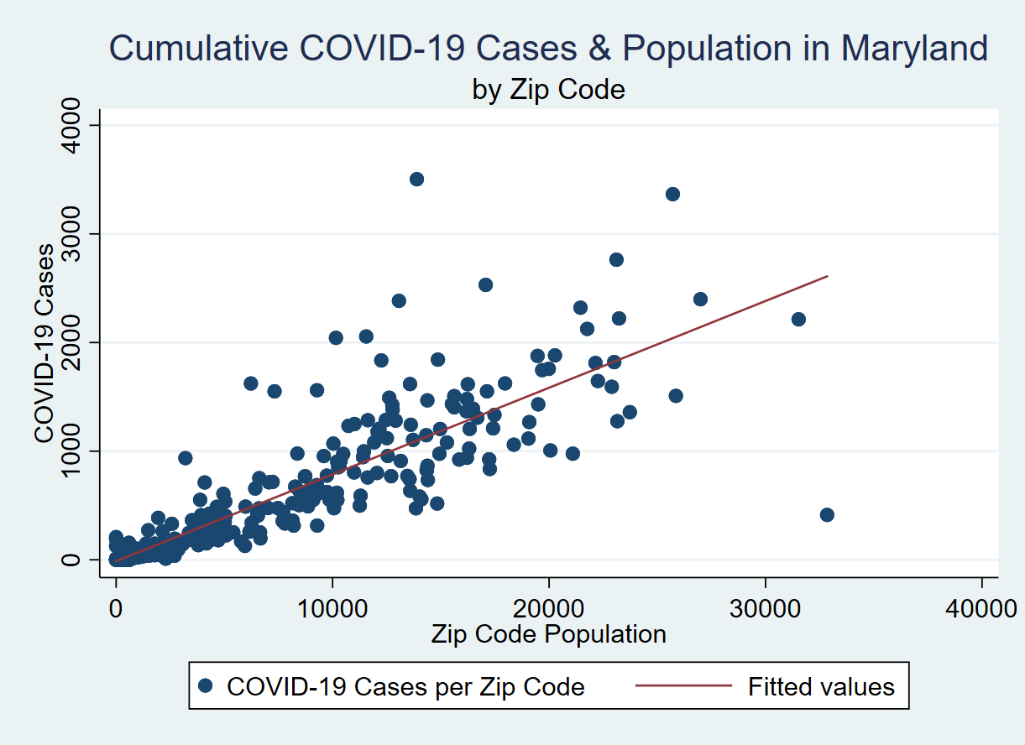

*Figure 6--Regression Model of Cumulative COVID-19 Cases and Zip Code Population*

*N = 434, F(1, 432) =1406.52, p < .0005, R2 = 0.7650*

Based on these results, we can draw several conclusions: (1) the presence of parks is not positively associated with localized COVID-19 cases; (2) park visitation has a very weak positive association with COVID-19 cases, but increased use of parks do not; (3) parks located in or near highly populated areas see higher visitation numbers; and (4) higher population density appears to have a much stronger positive association with COVID-19 cases than any other variable.

***Discussion & Conclusion***

It must be noted that, due to the grouping of our units of analysis by zip code, observations for parks were not independent, and therefore values associated with certain parks are accounted for multiple times. The results of our statistical tests concerning the parks should therefore be treated as incipient; however, the zip code and population tests should be very reliable for the given timeframe. Moreover, monthly COVID-19 data were only available for the months of April - November, while park visitation data were only available through their date of access (November 23, 2020), therefore presenting some gaps in the data. Finally, alternative grouping of the continuous variables of interest may alter the results of certain statistical tests, as the Chi-2 test between net visitation change and COVID-19 cases was quite close to being statistically associated (0.052).

Given a larger time frame and more data available concerning COVID-19 and parks, there are some possible routes we could have taken to improve our analysis. One such way could be to incorporate data from coronavirus vector tracking in order to analyze the impact of park visitors who had tested positive for the coronavirus, especially looking at the probability of spreading the disease in parks compared to other public spaces. Additionally, if more specific park data could be acquired, we could also analyze the neighborhood visitors came from in order to determine trends associated with spatial data. Moving forward, we have discussed giving our data and conclusions to the Maryland Department of Natural Resources (DNR) in order for it to potentially be used to analyze deeper park statistics. Since for some of the scenarios mentioned above, there is no public visitation data, the DNR is likely to have more applicable private data for parks that can be shown alongside our visitor change datasets to provide more meaningful connections. In some areas, this may be used to emphasize the importance of maintaining social distance or reducing travel to public areas except for essential visits. As the COVID-19 pandemic continues to unfold and more information regarding it becomes available, investigations of this sort will be valuable in both adapting in real time and preparing for future crises to come.

**References**

Geng, Dehui, John Innes, Wanli Wi, and Guangyu Wang. (2020). “Impacts of COVID-19 pandemic on urban park visitation: a global analysis.” *Journal of Forestry Research*, 1-15. <https://doi.org/10.1007/s11676-020-01249-w>

WBALTV. (2020, Dec. 2). Timeline: Coronavirus in Maryland. <https://www.wbaltv.com/article/timeline-coronavirus-in-maryland/31394971>